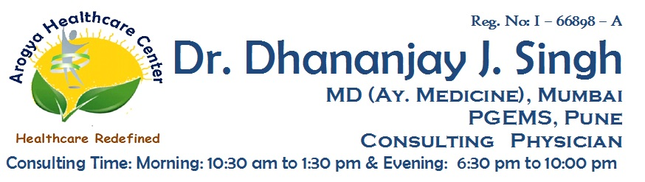

**Reg No: I-66898-A**

**Dr. Dhananjay J. Singh**

**MD (MEDICINE AY.) MUMBAI, PGEMS CONSULTING PHYSICIAN**

Date : / /202

**MEDICAL CERTIFICATE**

**To Whomsoever It May Concern**

This is to Certify that

Mr/Mrs/Mast/Miss ............................................M/F age...........Years.

taking treatment for ........................................................................

under my observation at **Arogya Healthcare Center**. He / She has

taken treatment from ...............................to ...................................

He / She is advised to take rest during and after treatment for .......days.

He / She is presently hemodynamically stable. He / She can considered

to be medically fit to resume his/her school/office from .......................

**Dr. Dhananjay J. Singh**

**Address :** Shop No:3, Redwood Building, Orchid Residency, Charnipada, Bhiwandi, Dist - Thane